#6 Delta
Special Instructions

Write Spanish Addresses Here

Work only the INSIDE of the boundaries unless map says otherwise.
(North East)
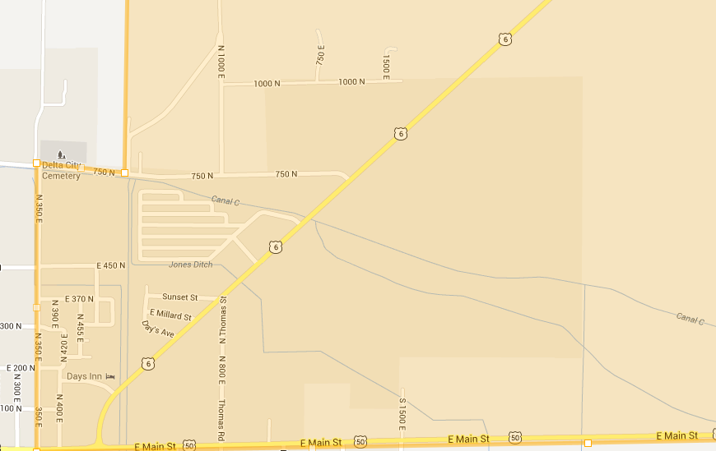
Work until East Boundary which is the Highway
Includes Golf Course houses.

